EAFA Mash-Up Filmmaking Competition 2017
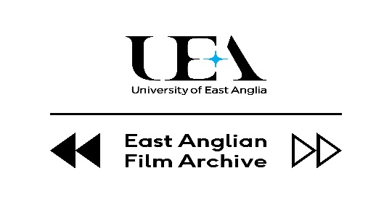
Fancy becoming an award winning filmmaker? TODAY’S THE DAY!
The East Anglian Film Archive (EAFA) is pleased to announce the launch of Mash-Up 2017. The filmmaking competition has run successfully for the last two years but it's back bigger and better for 2017 with more archive footage to fuel your creativity. This is an exciting opportunity to make a short film that turns archive material into something new.
“EAFA's mash-up competition is a great opportunity for novice and experienced filmmakers to hone their art, get their film publicly screened at the Norwich Film Festival and compete for prizes, including having their film preserved in the archive.” (Tim Snelson Director of EAFA)
For inspiration you may wish to view a short film EAFA has produced to introduce the Mash up competition. https://www.youtube.com/watch?v=Fywz_a_Hcco
The winning entry will also be available to watch on our website and the lucky winners from each category will receive a £250 cash prize!

This year’s theme is: TODAY’S THE DAY! We’ve deliberately left the theme a little open-ended so that filmmakers can interpret the theme in a variety of ways. Submissions won’t be judged on production values alone. What we’re looking for is creativity, imagination, and overall how you choose to interact with the archive film. You could re-edit them in an innovative way, or perhaps add effects, or audio/visual material you have sourced (with the necessary permissions) from elsewhere.

Terms and conditions:
The film needs to be between 1 to 5 minutes long and at least 50% of the total running time has to be made up of EAFA’s archive material that will be provided to you. You can then ‘mash-up’ these clips with footage you’ve shot yourself.
To watch YouTube clips of the archive material you can use to create your film visit: https://goo.gl/VW7Sco
How to apply:
Simply visit our website and download the entry form to send in to us. You will then be sent a competition package with high quality links to the archive clips and further information about the competition.
We have two entry categories:
-Under 18
-Over 18
We welcome entries from groups as well as individual filmmakers.
The closing date for submissions is 1st September 2017
For more information please visit: http://www.eafa.org.uk/events-news.aspx
Follow us on Twitter: @EAFA_mashup and Facebook: @eastanglianfilmarchive for regular updates on the competition.
Happy Filmmaking!
About the East Anglian Film Archive
The East Anglian Film Archive covers the East of England region (Bedfordshire, Cambridgeshire, Essex, Hertfordshire, Norfolk and Suffolk); it is owned and operated by the University of East Anglia, Norwich. Since 1976 the archive has collected moving images of the region and across the range of amateur and professional production. EFA’s collection included thousands of films and television programmes from 1896 to the present day, including unique collections from Anglia Television, BBC East, and the Institute of Amateur Cinematographers’.
For further information please contact eafa@uea.ac.uk or Angela Graham on 01603 592664

